When to use vanilla OLS vs regularized OLS:
- Vanilla OLS works the best out of all models when assumptions are not violated… for our purposes, the most significant and easiest assumptions to check are bolded
  - Linear relationship
  - Multivariate normality
  - No autocorrelation
  - No multicollinearity
    - VIF is an option to reduce multicollinearity… but what if we want to keep all our features? Or are worried that we are not removing the correct ones?
  - Homoscedastic
  - Number of observations > number of predictors
- PCA is an option to eliminate multicollinearity and perform dimensionality reduction… however, it can be difficult to interpret the coefficients as they correspond to principal components and are a mixture of different variables
  - You can analyze the loadings of each component to determine what variables are important to the component
- Two reasons we are often not satisfied with vanilla linear regression:
  - Prediction accuracy: vanilla OLS has low bias but large variance, meaning classifier would change significantly if trained on a different training set
  - Interpretation: OLS will incorporate all the features, and we might want to see what smaller subset of predictors has the most impact
    - Solutions include subset selection (forward can always be used) and regularization
    - Subset selection has high variance, regularization has less

- Subset selection is less useful than regularization
- Regularization can allow OLS to generalize to n << p situations or situations with high multicollinearity. Depending on the type of regularization, it can also perform feature selection
- L1 regularization (lasso):
  - Handles multicollinear datasets
  - Feature selection model: selects at most n features if you have n observations, all other feature coefficients will go to 0
  - Only selects one feature (somewhat arbitrarily) out of a collinear group of features
  - May lead to reduced accuracy in favor of interpretability/simplicity
  - Not stable – does not have one unique solution.
    - In practice, Randomized Lasso is used to increase stability (but is more computationally expensive)
    - Number of features selected is then not limited by n
  - Good to use: when you want to select a subset of features or believe that only certain features in your model have predictive importance, when your data has significant outliers
- L2 regularization (ridge):
  - Handles multicollinear datasets
  - Stable
  - Does not eliminate features but shrinks their coefficients
  - Good to use: when you believe all your features may be important or do not want to perform feature selection, when your data has noise but not significant outliers
- Elastic net is a combination of L1 and L2 regularization, offers an in-between of feature selection and feature shrinkage
  - Does not have a feature constraint like lasso
  - More computationally expensive (requires parameter tuning)
  - Can have trouble with highly correlated variables: unstable, signs can change
  - Good to use: when you believe certain features in your model have predictive importance but want to be robust against bias when selecting among collinear variables, when your data may have significant outliers
- When dataset is larger than 100K rows, use SGDRegressor with ‘elastic net’, ‘lasso’, ‘ridge’ parameters rather than ElasticNet, LassoRegression, RidgeRegression functions directly
- When working with n > p with significant outliers, Huber regression is also typically used… couldn’t find any information on how it is affected by multicollinearity; although, there are several articles discussing how to handle the outlier-multicollinearity problem that are variations on Huber regression, so I assume that it is affected by multicollinearity like OLS.

Overall question: what is more important for the user—model accuracy or interpretability?
- Do we want high predictive accuracy for our model? Then a tree-based model like CatBoost or XGBoost might be better as there are less model assumptions
  - But these models are much harder to interpret as they are non-parametrized
- Do we want high interpretability? Then a regression model would be the best option
  - Do we expect n < p, user to ask for feature selection, outliers that we want to include in our model, or high multicollinearity? Then use regularization
  - Otherwise, we can stick to vanilla OLS

Workflow:
- Remove columns with no variance
- Check for outliers using Isolation Forest and IQR (only if selected by user)
- Check for multicollinearity using VIF
- Determine what type of regression model we plan to use (Randomized Lasso, Elastic Net, Ridge Regression, vanilla OLS) based on user interests
  - If dataset greater than 100K rows, use SGDRegressor
- Scale numerical data
- Train/test split
- Run model
- If Durbin-Watson returns a high chance of autocorrelation, suggest a time series model.

Some observations based on our datasets:
No multicollinearity, n > p
Without dropping outliers, linear regression overfits significantly. Without multicollinearity, Huber regression does the best (which makes sense given its goal as a regression model). Elastic Net tends to do the second best (which makes sense given that it is a mix between Lasso and Ridge regression).
Without outliers in the training data and without multicollinearity, Linear Regression tends to do the best.
With multicollinearity, n > p
Without outliers, Ridge Regression and Elastic Net do the best.
With outliers, Huber controlled for multicollinearity typically do the best.

Overall:
Linear regression tends to overfit when assumptions are not met… and usually assumptions are not met
Outliers may be important, so we shouldn’t arbitrarily drop them. Better to run the model with and without outliers and compare the results.
In practice, Elastic Net is often used over Lasso and Ridge regression because with the right parameters it becomes Lasso and Ridge regression. It’s also fairly robust to outliers. Overall, would select Elastic Net unless some of these edge cases are specified by the user.

If we want to keep the outliers?
Huber with VIF: stable, better accuracy
Randomized Lasso: removes features that don’t contribute to the prediction - not just those that are highly multicollinear
If we want to keep all features but are worried about multicollinearity?
Ridge Regression (note that it is susceptible to outliers).
If we are worried about multicollinearity but okay with dropping some features?
Randomized Lasso: handles outliers, doesn’t change signs w/ highly multicollinear variables
Elastic Net: selects more features, more stable, handles outliers, selects more than one multicollinear variable from group
Linear Regression w/ VIF: stable (note that it is susceptible to outliers)
If we have more predictors than observations?
Ridge: selects all features (stable), outperforms lasso with high multicollinearity
Randomized Lasso: handles outliers
Elastic Net: handles outliers, more stable than lasso, selects more than one multicollinear variable from group

LLMs:
GPT 4o: https://chatgpt.com/share/d050cd17-4d27-4c65-8f36-1c8e5eabfa03
- First tries to run Random Forest (requires prompting asking for model interpretability)
- Then tries to address multicollinearity through VIF but a) not through an iterative approach and b) only removes values with VIF of infinity… there are still several highly correlated features
- Then uses Ridge Regression when I prompt it to keep all features. Still does not scale the data after the train/test split
  - Train/test split should always be done before anything else to prevent data leakage
  - Doesn’t check for outliers despite ridge regression being susceptible to them
- After prompting it does pretty well but need to specify the steps and considerations ahead of time
Julius:
- Checks for multicollinearity, outliers, etc. while using a vanilla OLS model
  - Uses statsmodels OLS so there isn’t a way to do the train/test split before checking for all of this
- Goes to Random Forest first before interpretability consideration is explained
Copilot:
- Also initially selects Random Forest
- Then chooses linear or lasso regression
- Depending on my prompt, gives the correct regression model response

Encoding categorical features:
- Feature selection: SelectKBest can help choose a subset of features… or PCA could be used for dimensionality reduction
- Issue: many categories in your data
- Group rare categories into “other” bucket
  - Prevents overfitting
- Use CatBoost encoder to turn categorical variables into continuous ones (Target Encoder that mitigates the target leakage from a typical Target Encoder process)
  - This eliminates the space issue of one-hot encoding but it doesn’t necessarily tell us which subcategories are the most impactful – will continue doing research on this
  - One-hot encoding is the best performance wise on multiclass datasets but there is no discernable difference between target encoding and one-hot encoding in binomial settings
- Treat ordinal variables as continuous variables
----------------------------------------
Steps for adding categorical variables:
- Can either group rare categories into an “other” bucket or not – no clear way to discern whether one option is better, perhaps best to run both and see which has better results
  - In the AirBNB dataset, it didn’t help (reduced accuracy by 5-7%) – in this case, other category had meaningful information
- Use CatBoost encoder to turn categorical variables into continuous ones
  - CatBoost encoder works as a encoding that replaces the features’ categories with a metric derived from the target… in contrast to typical Target Encoding, the CatBoost encoder reduces target leakage
  - It directly works with regression and binary outcomes
  - For multiclass outcomes, need Target Encoding
  - One-hot encoding (w/ a “other” bucket) has the best performance over all model types (regression, binary and multiclass classification) and provides more specific feature information about subgroups
- Then throw features into linear regression

AirBNB data
CatBoost encoder, regression target variable, outliers removed:
R^2 Train: 67%, Test: 45% for regular linear regression… a significant improvement on just continuous data.
Grouping rare categories into “other” turns this into train: 68%, test: 38% (overfitting).
Train: 62%, Test: 43% for randomized lasso regression.
These still aren’t great… but we previously had significantly lower train/test scores.
All models tend to have similar top features (different order but same features).
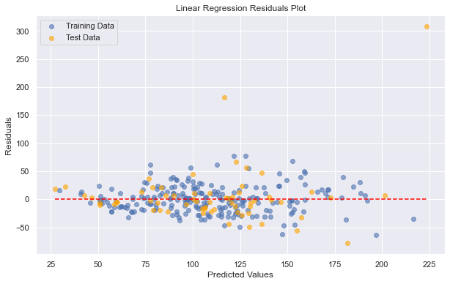
Our models have high variance (large gap between train and test scores), so improve the model performance, we’d most likely need to add more data or try bagging methods.
I had also used CatBoost in the past as another type of predictive model. I explored CatBoost again, but this time with SHAP plots for each variable as well.
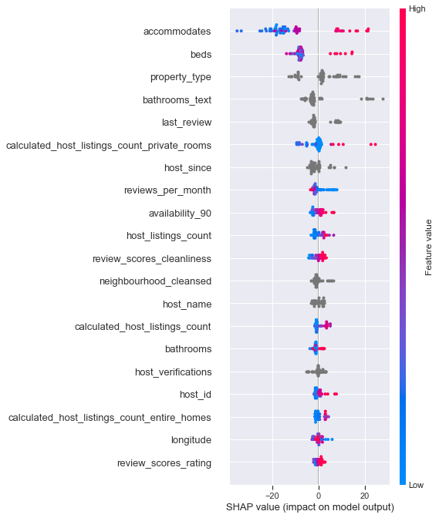
This plot shows us the continuous variables and what impact they have on the prediction. A positive SHAP value corresponds to a positive prediction and vice versa. We can see that low accommodates values correspond to a low price, for example.
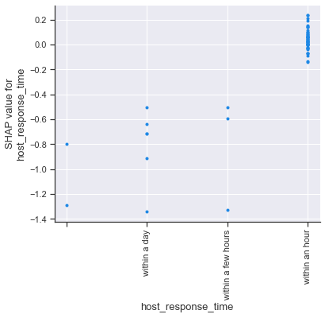
This plot shows us a similar breakdown for each category of a categorical variable. We can see that responding within a day tends to correspond with lower price predictions.
These values don’t tell us precisely how one value influences another (as in through linear regression) but are still interesting and can have a similar purpose. This also gives us the subgroup categorical variable breakdown we were looking for.
CatBoost also has much higher train/test accuracy than our linear regression models. (High variance as well though which can usually be solved by adding more data or bagging.) Biggest issue with boosting models is sensitivity to outliers.
Train R-squared: 0.8650660575458691
Test R-squared: 0.5525345269338575
Added in CatBoost and Logistic Regression for categorical variables as well. Still want to investigate anomaly detection with logistic regression… was having some trouble with that.
Logistic RegressionCV takes a long time but has higher testing accuracy than CatBoost on the pet adoption dataset (82% vs. 80%). Both have a minimal gap between training and testing.
- Text/descriptions… can turn them into feature vectors using Word2Vec
  - Then summing or averaging the feature vectors can often have pretty good results in terms of transforming them into continuous data that represents a document/blurb
  - Then they can be incorporated into an existing regression model or other model and used!
  - Can normalize the vectors and scale them if we aren’t interested in significance or consistency
  - Doc2Vec also an option but more space and time is needed to properly train the model
Taking AirBNB descriptions and adding them as features in the linear regressions is NOT helpful: even reduces model accuracy in some cases (Linear Regression and Randomized Lasso both lost 2% on test).
Just AirBNB descriptions by themselves are also not helpful: Test accuracy is around .03% for all models and train accuracy is not much better.
---- NOTE: Regression on a count outcome requires Poisson Regression ----
Interested in seeing longer descriptions – if that does better. Interested in also seeing what happens if we run PCA on the description vectors to reduce their size even further.
https://www.kaggle.com/datasets/ravindrasinghrana/job-description-dataset
https://www.kaggle.com/datasets/anu0012/hotel-review?select=train.csv

LLMs:
GPT 4o:
- Default is to use one-hot encoding even when that might blow up the size of the dataframe
- Prompted it to use category_encoders package… doesn’t have category_encoders installed (?) so tried to use ordinal encoding instead
  - Tried to use target encoding at first though which would make sense
- Then tries to use a basic Decision Tree model
- Doesn’t have access to word2vec so uses scikit-learn library instead
  - Word2Vec works better with larger documents as you can reduce dimensionality
- Uses a Random Forest model with about equivalent test accuracy as our linear regression model: 42%

